Computer Skills Tutorials

Ella Foster-Molina

Table of contents

Introduction 2

1. Environment Setup 3

2. Organization within a Document 7

3. File Management 11

4. Mouse/Trackpad Skills 19

5. Keyboard Skills 21

# Introduction

These tutorials are designed to turn you into an efficient and effective computer user. They will reduce the time spent writing essays and aid writing clarity. If you pursue more advanced computing, such as complex research projects or coding, they will save time and headaches.

## Choose your approach

This document has the same content as the [online version](https://swat-ssql.github.io/computer-skills-tutorials/) but a different organization. Like the online version, it can be completed in a variety of ways.

* Complete each section independently.
* Start at the beginning, “Environment Setup,” and work your way through.
* Note that “File Management” and “Environment Setup” provide the biggest gains in efficiency. They also take longer to complete. Both are designed for PCs and Macs, which have sophisticated file management systems and flexible environments.
* Start with “Keyboard Skills” and “Mouse/Trackpad Skills”. These are short and will provide the quickest gains in efficiency for most users. These sections and “Organization within a Document” can be completed on a tablet or computer.
* Complete the [Computer Skills Assessment](https://swat-ssql.github.io/computer-skills-assessment/) now, later, or in parts. Just like these tutorials, the assessment is modular. If you are familiar with the skills and simply want a quick self assessment, skip these tutorials and head to the assessment.

## Theory and practice

Each section below is divided into two subsections: theory and practice. Just like learning the piano, computer skills require both.

Theory: Gain knowledge of the theory of computing by working through the tutorials. You can also Google topics such as “[computer shortcuts,](https://letmegooglethat.com/?q=computer+shortcuts)” “[file management,](https://letmegooglethat.com/?q=file+management)” and “[navigation pane](https://letmegooglethat.com/?q=navigation+pane)” to find additional tips and tricks.

Practice: Each section ends with a set of tasks. Complete them. In some cases, practice them repeatedly. Incorporate these skills every time you use your computer. Some sections will suggest that you play computer games such as Minesweeper or Solitaire. Computer developers originally made these games available on the computer to incentivize users to learn key mouse/trackpad skills.

## Assessment

Assess your skills by completing the linked [Computer Skills Assessment](https://swat-ssql.github.io/computer-skills-assessment). If you cannot complete the tasks in the assessment, do not fret. Simply come back to these tutorials, practice, and return to the assessment later.

# 1. Environment Setup

This section overviews some useful modifications to your general computing environment. It is designed for a Mac or PC computer, not a tablet.

All sections of this tutorial, including this one, are designed to be completed independently. Since portions of the skills in this section are required for the other sections, pieces of these skills will also be shown in subsequent sections. You can simply skip over those sections if you start here.

## 1.1 Theory

The default settings on many programs are designed for simple usage, not for more advanced use. For example,

* the path for your files is often hidden by default, and
* some Mac mice/trackpads do not have easy access to a right click button,
* the navigation pane for Word and Google Documents is sometimes hidden.

All of these settings can be quickly modified.

### Window management

It is often efficient to arrange your application windows so that two or more are easily visible on the same screen. This lets you see the origin of your information at the same time as you see the new location for your information. When information is visible at both its origin and destination, you can copy-paste and drag-drop that information efficiently. This helps

* manage files and folders,
* copy and paste information from a browser into a Google Doc/Word document,
* simultaneously view tutorials and apply the skills in real time,
* and much more.

This may take some practice. Typical modern computer users swipe between screens. While this is useful for consuming information and some parts of writing, it can be impractical for creating and managing information.

Note that many expert computer users take this to an extra level. They use two or more computer screens to enhance the amount of information displayed and available for organizing. For example, I currently have the Word version of this document open, along with the Computer Skills Assessment, a set of notes from a workshop on computer skills, and an application to edit the screen grabs included in this document. These documents are organized across two screens for easy access to information.

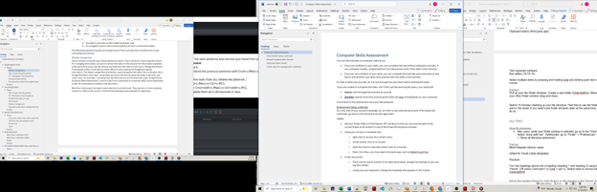

### Path bars

The path bar has many uses. You can:

* see where your files are located at all times,
* copy the location of your files in text form, and
* navigate up your folder tree by clicking on higher level folders in the path bar.

On a Mac, the path bar is hidden by default. You can change this default by clicking View -> Show Path Bar in the Finder menu options. The path will appear at the bottom of the screen. Navigate up your folder structure by clicking on folders in the path bar. Copy the path address by right clicking on the path and selecting “Copy path.”

On a PC, the path bar is always visible. Navigate up your folder structure by clicking on folders in the path bar. Copy the path address by clicking into the blank white space next to the path bar and pressing Ctrl+c.

|  |  |
| --- | --- |
| Mac  Mac | PC  PC |

Additional information on organizing your files can be found in “File Management” > “File Structure”.

### Mouse/trackpad settings

* Search for your mouse/trackpad settings by searching for “Mouse Settings” in your spotlight search. See if you want to adjust any settings.
* On a Mac, mice/trackpads may not have easy access to a right click. You can compensate by pressing Ctrl+click, but this is inefficient. For a more accessible right click, adjust your settings or install a third-party app such as BetterTouchTool.

### Word processor setup: the navigation pane

Document headers provide many benefits, including:

* idea organization,
* document navigation by clicking on the relevant part of the outline in the side panel,
* interactive tables of contents,
* document accessibility.

In **Microsoft Word,** you can see a navigation pane with all headers, which creates an interactive table of contents. To access the navigation pane, go to the View ribbon. In the “Show” section, click “Navigation Pane.” Make sure you are in the Document Map (Mac) or Headings (PC) section of the panel on the left

**Google Docs** opens the navigation pane by default. You may need to click the list icon at the top left of your screen.

|  |  |
| --- | --- |
| Microsoft Word (PC)  Microsoft Word (PC)  Microsoft Word (Mac)  Microsoft Word (Mac) | Google Docs  Google Docs |

## 1.2 Practice

Tasks:

1. Make sure this tutorial is saved in a logical place on your computer or a cloud environment. The section on “File Structure” under “File Management” may be helpful.
2. This document should be open in Google Docs or Microsoft Word. If you are very comfortable with a specialized text editor, feel free to use it. All sections other than “Organization within a Document” are possible in specialized text editors.
3. Save a copy of this document with the current date at the end. For example, it could be “Computer Skills Tutorials 2025-06-17.docx”.
4. Ensure that the navigation pane is open and visible on the left side of the screen.
5. The document you saved starts with this section. Start working through the next sections!

# 2. Organization within a Document

Document headers provide many benefits, including:

* idea organization,
* document navigation by clicking on the relevant section in the side panel,
* interactive tables of contents,
* document accessibility.

You can apply these skills with a few keystrokes within Google Docs or Microsoft word. All you need to do is press Ctrl+Alt+(number) on a PC or Cmd+Alt+(number) on a Mac.

### Examples

These are some examples of how headers can help.

1. Jump around this document to work on individual sections.
2. Use headers to organize notes on a (hypothetical) American Wars course by date. At a glance, you can jump from your class on October 6th on the WWI to your class on November 3rd on the Vietnam War.
3. When writing a research paper, you can jump from your introduction to your conclusion with a click. This can help you ensure that your introduction and conclusion make a similar argument.
4. In Microsoft Word, you can collapse all sections of your document other than the one or two that you are currently working on.



Microsoft Word

Most other advanced text editors have their own methods of creating document headers for navigation. This document will focus on two basic word processors: Microsoft Word and Google Docs. Note that Microsoft Word is still the industry standard as a word processor. Google Docs makes sharing easier but is not as fully featured as Microsoft Word.

## 2.1 Theory

### Environment setup: navigation pane

To see the navigation pane in Microsoft Word, go to the View ribbon. In the “Show” section, click “Navigation Pane.” Google Docs opens the navigation pane by default. You may need to click the list icon at the top left of your screen.

|  |  |
| --- | --- |
| Microsoft Word  Microsoft Word | Google Docs  Google Docs |

### Mouse/trackpad headings

You can select a heading from the “Styles” section of the “Home” ribbon. This is easy but takes time.

### Keyboard headings

Headings are especially useful if you memorize the keystrokes to generate the headings.

|  |  |  |  |  |
| --- | --- | --- | --- | --- |
| **Type** | **Microsoft Word**  **(PC)** | **Google Docs**  **(PC)** | **Microsoft Word**  **(Mac)** | **Google Docs**  **(Mac)** |
| Heading level 1 | Ctrl+alt+1 | Ctrl+alt+1 | Cmd+alt+1 | Cmd+alt+1 |
| Heading level 2 | Ctrl+alt+2 | Ctrl+alt+2 | Cmd+alt+2 | Cmd+alt+2 |
| Heading level 3 | Ctrl+alt+3 | Ctrl+alt+3 | Cmd+alt+3 | Cmd+alt+3 |
| Normal | Ctrl+shift+n | Ctrl+alt+0 | Cmd+shift+n | Cmd+alt+0 |
| Heading dialogue box | Ctrl+shift+s |  |  |  |

Note that Google Docs lets you create additional heading levels using the same pattern. Microsoft Word stops keyboard shortcuts after heading level 3, although Ctrl+shift+s provides a handy alternative for lower-level headings.

A handy trick in Microsoft Word is to change the case pattern of selected text using shift+f3. You can cycle between UPPER CASE, Camel Case, and lower case.

### Change format of all headers

On either platform, you can adjust heading formats easily with the following steps:

1. Move to one of the existing headers in this document, such as “Theory”. Change the format; you can bold it, for example. Keep your cursor blinking on that header.
2. To make all headers with that level match your new format
   1. Microsoft Word: Select the “Home” ribbon. In the “style” section, right click on the appropriate header. Click “update to match selection.”
   2. Google Docs: Click into the heading section of the ribbon. Move your cursor to the appropriate heading. Click “Update heading __ to match.”
3. All headings of that level will now match the format of the heading your cursor started on.

|  |  |
| --- | --- |
| Microsoft Word  Microsoft Word | Google Docs  Google Docs |

## 2.2 Practice

Tasks:

1. Make the “Tasks” line above into heading level 3 with just your keyboard.
2. Change the format of the “Tasks” line.
3. Apply that format to all level 3 headings in the document.
4. Undo your changes with just your keyboard.

The following gif shows an example of these tasks in Microsoft Word.



# 3. File Management

## 3.1 Theory

The developers of modern computers have gradually added barriers to creating reasonable file structures on a computer. Yet file management is critical to

* organize ideas,
* store and organize multiple documents associated with a single project,
* create a unique internal address that pinpoints the location of a file or folder,
* effectively code, and
* manage complex research projects.

File management is almost entirely inaccessible on most tablets and smartphones. It is still entirely possible on a computer but requires a few additional clicks and environment adjustments. As such, this section is designed for a Mac or PC computer, not a tablet. Similar principles apply to a Chromebook, but are not demonstrated here.

Tags provide useful additional organizational structure but can never replicate the unique internal address created by a file structure.

### Path bars

The path bar lets you see where your files are located at all times, allows you to copy the address in text form, and lets you navigate up your folder tree by clicking on higher level folders in the path bar. It is useful in many contexts, and critical for coding projects. Alternate methods exist for each of these tasks, but the path bar accomplishes all of them and is similar on Macs and PCs.

#### PC

The path bar is always visible in Window’s File Explorer. To access the text version of the path, click into the blank white space next to the path bar.

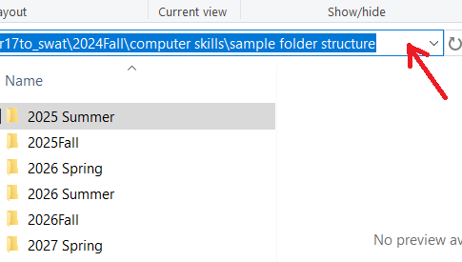

#### Mac

The path bar on a Mac is hidden by default but can be displayed by clicking View > Show Path Bar in the Finder menu options. The path will appear at the bottom of the screen. The path can be copied by right clicking on the path at the bottom of the screen and selecting “Copy path”.

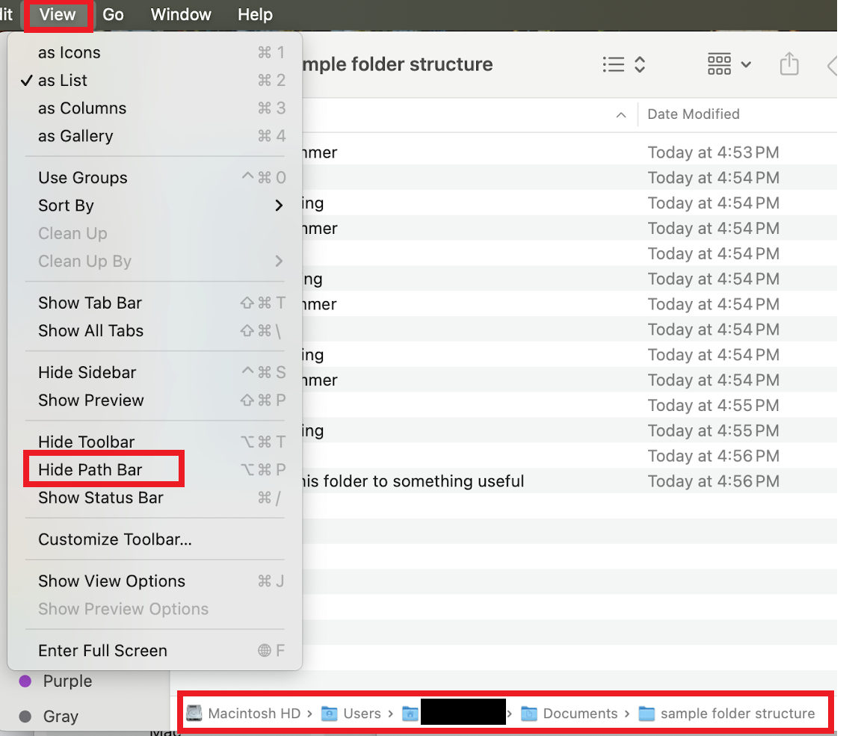

#### Google Drive’s path, of a sort

Google Drive also has a folder structure, but it is not nearly as useful or accessible as Mac’s Finder or Window’s File Explorer. It is difficult to copy the path address (as of Summer 2025). That said, the path does appear at the top of your Google Drive screen. You may need to click three little dots to the left of the path to access the full path information.

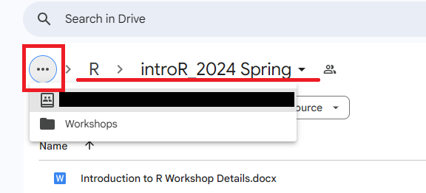

### File structure

#### Documents folder

On a Mac and PC, you should default to creating a file structure in the “Documents” folder. This is the location intended for permanent file storage for most users. There are alternatives, such as storing your files in a synced Google Drive or Dropbox account.

Note that your Downloads folder is intended for temporary storage. Many of the files you download, such as installers, are intended to be temporary files. Yet they can take up a lot of space. As such, good computer hygiene involves deleting your Downloads folder on a regular basis. This makes your Downloads folder uniquely unsuitable for permanent storage.

#### Clean out the Downloads folder

If you store your files in your Downloads folder, you do not have to fix it all at once. Create a plausible file structure in your Documents folder, as described below. Move all contents of your Downloads folder to a folder named “Downloads (insert date)” inside your Documents folder. For all future downloads of potentially permanent files, save them in your Documents folder in a reasonable location. Over time, you can remove things from the copied Downloads folder that now lives in your Documents folder. Delete unneeded files. Move others to reasonable locations in your Documents folder. Remove temptation to use your Downloads folder as permanent storage by regularly deleting all the files that end up there. They should all be temporary anyways.

#### Folder system principles

* Leverage the alpha-numeric ordering required by the Finder (Mac)/File Explorer (PC) programs.
  + Start file and folder names with the year when applicable. Add the month and/or date after the year. Use spaces and punctuation strategically. For example, “2026 Summer” comes before “2026Fall”, because a space “ ” comes before “F” in the alpha-numeric order.
  + Start commonly used files and folders with the beginning of the alphabet. Even putting “1” or “aa” at the beginning of a file or folder can be effective, albeit inelegant.
* Human brains track time-based categories well. When topics are nicely confined inside a time period, you can contain them in folders devoted to a year, season, semester, or quarter.
* Balance the depth of your folders (how many folders are nested within each other) and the breadth of your folders (how many folders are within one single folder). Too deep, and you will spend too much time clicking into folders. Too broad, and you will have a hard time finding the folder you want. One suggestion is to keep your regularly/recently used files fairly broad. Bucket your older/less used files into a few folders.
* Google “[computer file structure principles](https://letmegooglethat.com/?q=computer+file+structure+principles)” to find more information about file structure systems.

#### Example folder system

The following is an example of a folder system that has been used successfully by many students and faculty. You can download this example at this link: [sample folder structure](https://github.com/swat-ssql/sample-folder-structure/raw/refs/heads/main/sample%20folder%20structure.zip). Change the years to fit your situation. Adjust semester to quarters or any other subdivision as needed. Select the folder and press “F2” on a PC and “Enter” on a Mac to rename the folder.

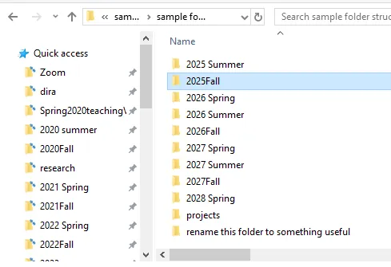

### Quick access/Favorites

Drag and drop regularly used folders into your “Quick Access” (PC) or “Favorites” (Mac) panel on the left side of your Finder (Mac)/File Explorer (PC).

|  |  |
| --- | --- |
| Mac  Mac | PC  PC |

### Window management

Typical modern computer users swipe between screens. This is useful for consuming information. For managing information, you want to show the original location at the same time as the new organized location.

For files and folders, this means displaying a file’s origin at the same time as you see the window with its destination. You can then efficiently move and organize files and folders. For example, with the window configuration below, I can rapidly drag and drop the “Computer Skills” folder into my “all workshops” folder.

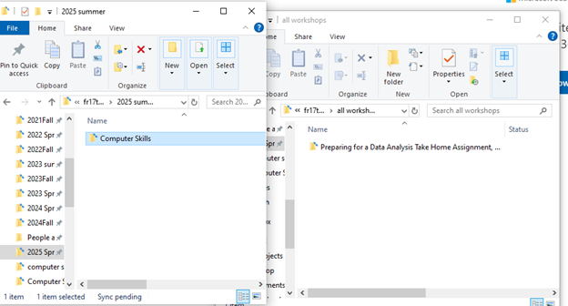

### Saving files in Microsoft Office

Microsoft Office has begun to hide the file structure when you save a document. When you save a document (Save or Save As), the first screen tries to guess where you want to save it. If you have a clear file structure, its guess should only be accurate if you were working in the same location repetitively. This section demonstrates how to access your file structure via the Browse button (PC) or a downward facing button (Mac).

An alternative to this section is to change the setting permanently. Google “[customize the save experience in office](https://letmegooglethat.com/?q=customize+the+save+experience+in+office)”.

Your screen may look slightly different than what is shown here. If it is too different to interpret, Google “[Browse file structure from save word](https://letmegooglethat.com/?q=Browse+file+structure+from+save+word)” to find a guide suited to your computer’s environment.

#### PC

On a PC, click “Browse” from the “Save” or “Save As” screen. In the resulting File Explorer window, browse to the appropriate folder and click “Save”.

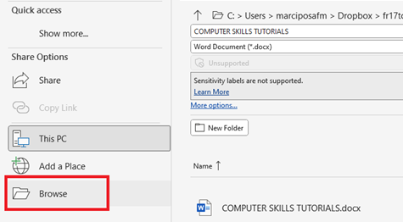

#### Mac

On a Mac, click the downward facing arrow next to “Where” from the “Save” or “Save As” screen. In the resulting Finder window, browse to the appropriate folder and click “Save”.

|  |  |
| --- | --- |
|  |  |

### Keyboard commands to navigate the Finder/Folder Explorer windows

|  |  |  |  |
| --- | --- | --- | --- |
| **Shortcut type** | **Key combo (PC)** | **Key combo (Mac)** | **Action** |
| *Moving between screens/windows* | Alt+`  (on some PCs) | Cmd+` | Move forward between Finder (Mac)/File Explorer (PC) windows |
|  | Alt +shift+` | Cmd+shift+` | Move backward between Finder (Mac)/File Explorer (PC) windows |
|  |  | Cmd+tab | Switch between open applications. The most recently used window of that application will be brought to the front. |
|  |  | Cmd+shift+tab | Move backwards between open applications. |
| *Navigate folders within Finder (Mac)/File Explorer (PC) windows* | Ctrl+n | Cmd+n | Open a new Finder (Mac)/File Explorer (PC) window |
|  | Ctrl+shift+n | Cmd+shift+n | Create a new folder |
|  | Two mouse clicks, too slow to be mistaken for a double click | Two mouse clicks, too slow to be mistaken for a double click | Rename the folder (this is a mouse action, but it is important enough to include here) |
|  | Select the folder, press F2 | Select the folder, press enter/return | Rename the folder |
|  | Ctrl+a | Cmd+a | Highlight all folders |
|  |  | Cmd+t | Create a new tab within a window |
|  | Delete | Cmd+delete (the one next to your +/= sign) | Delete a folder |
|  | Shift+arrow | Shift+arrow | Highlight multiple folders |

## 3.2 Practice

Tasks:

1. If you are on a Mac, set up your Finder window so that the path bar is visible at the bottom of the window.
2. Set up and/or clean up your file structure. This will take a substantial amount of time. I recommend spending 10 minutes now to set up the general organization structure. Then schedule an hour in the next week to make progress on your organization. If you store files in your Downloads folder, pay particular attention to the section on cleaning out the Downloads folder.
3. Open a Finder (Mac)/File Explorer (PC) window. Arrange it so you can see these instructions and your Finder (Mac)/File Explorer (PC) window at the same time.
4. Copy the path of one folder. Paste the path name here ______.
5. Open a new window with Cmd+n (Mac)/Ctrl+n (PC). Open a different folder in one of the windows.
6. Create a new folder (in either window) using Cmd+shift+n (Mac)/Ctrl+shift+n (PC).
7. Rename that folder.
8. Move the folder to your second window by dragging and dropping it.
9. Cmd+z (Mac) or Ctrl+z (PC) to undo the move.

The following gif shows an example of tasks 5-8.



# 4. Mouse/Trackpad Skills

## 4.1 Theory

You interact with your mouse or trackpad hundreds, maybe thousands, of times per hour. Expert computer users can perform each of the following skills within one or two seconds. A gif of these skills in action are included in the “4.2 Practice” section at the end.

### Access the context menu with a right click

* Quickly access a variety of useful functions specific to the application you are using.
* On a Mac, you can press Ctrl+click to mimic a right click. Note that this takes a lot of time. If you are unable to access your right click on your mouse, you can adjust your settings. Alternatively, install a third-party app such as BetterTouchTools to create a gesture on your mouse or trackpad that will mimic a right click. A third-party app will also allow you to enable many other gestures. This includes the center click native to many PCs, which scrolls and opens new tabs in a browser.

### Left click, hold, and drag the mouse

* In a browser, text editor, or word processor, this will highlight text.
* In your Finder (Mac)/File Explorer (PC) windows and at the top of your computer programs/applications, this will let you drag items across the screen.

### Double and triple clicks

In a browser window, text editor, or word processor, this will highlight text. Depending on where you double click, different amounts of text will be selected. Note that some of these gestures may not work in all applications.

* Double click on a word, and that word will be highlighted.
* Triple click on a word, and the entire paragraph/chunk will be highlighted.
* Double click to the left of an entire line, and that line may be highlighted, depending on your application.
* Triple click to the left of an entire line, and the entire paragraph/chunk may be highlighted, depending on your application.
* Quadruple click far to the left of an entire line, and the entire document may be highlighted, depending on your application.
* Two clicks, too slow to be captured as a double click, access the renaming function of files and folders in File Explorer (PC) and Finder (Mac).

### Scroll

* Almost all computer users are able to scroll easily with a mouse/trackpad.
* Ctrl+Scroll (PC) or Cmd+Scroll (Mac) may adjust the zoom ratio of your screen.

## 4.2 Practice

Practice these skills in the prompts below. Another way to practice is with Minesweeper and Solitaire. You can find these games online by googling “Minesweeper” or “Solitaire”. They were designed to teach rapid mouse gestures, including:

* left click,
* right click,
* drag and drop, and
* precision with your cursor.

Tasks:

1. Using only your mouse/trackpad:
   1. Highlight this sentence by double clicking on this line.
   2. Highlight just the bolded le**tter**s in this line with a left click-hold-drag gesture.
   3. Highlight this sentence, right click to access the context menu, cut it, and copy it back onto this line.
2. Practice the skills above until you can do them in 30 seconds or less. The gif below demonstrates these tasks in 16 seconds.

# 5. Keyboard Skills

### Table of key combinations

These key combinations work in most applications on most computers.

|  |  |  |  |
| --- | --- | --- | --- |
| **Shortcut type** | **Mac** | **PC** | **Action** |
| Copy, paste, undo, redo | ***Cmd+c*** | ***Ctrl+c*** | ***Copy*** |
|  | ***Cmd+x*** | ***Ctrl+x*** | ***Cut and copy*** |
|  | ***Cmd+v*** | ***Ctrl+v*** | ***Paste*** |
|  | Cmd+option+shift+v | Ctrl+shift+v | Paste and match style |
|  | ***Cmd+z*** | ***Ctrl+z*** | ***Undo*** |
|  | Cmd+shift+z | Ctrl+shift+z  Ctrl+y (using Microsoft Office on a PC) | Undo the undo |
| Manipulate text | ***Cmd+i*** | ***Ctrl+i*** | ***Italicize*** |
|  | ***Cmd+b*** | ***Ctrl+b*** | ***Bold*** |
|  | ***Cmd+u*** | ***Ctrl+u*** | ***Underline*** |
|  | Cmd+k | Ctrl+k | Insert hyperlink |
| Select text | ***Cmd+a*** | ***Ctrl+a*** | ***Select all text*** |
|  | Cmd+shift+arrow | Ctrl+shift+down/up arrow | Select remainder of line to the left/right of cursor |
|  | Shift+option+left/right arrow | Ctrl+shift+left/right arrow | Select one word |
|  | ***Shift***+***up/down arrow*** | ***Shift***+***up/down arrow*** | ***Select text from cursor to line above*** |
|  | ***Shift+left/right arrow*** | ***Shift+left/right arrow*** | ***Select individual characters to the left/right of the cursor*** |
| Move cursor | Option+arrow | Ctrl+arrow | Jump cursor to the beginning/end of words or to lines above/below |
|  | Cmd+right arrow | End | Jump cursor to the end of a line |
| **Shortcut type** | **Mac** | **PC** | **Action** |
| Other | Cmd+ctrl+shift+4 | Win+shift+s | Screenshot selection to clipboard |
|  | Cmd+shift+4 |  | Screenshot selection to file on desktop |
|  | ***Cmd***+***f*** | ***Ctrl***+***f*** | ***Open the find text search bar*** |
|  |  | Ctrl+h | Open the find and replace menu |
|  | ***Cmd***+***p*** | ***Ctrl***+***p*** | ***Print the document (to a printer or to pdf)*** |
|  | Cmd+enter | Ctrl+enter | Page break |

## 5.1 Theory

Keyboard skills provide the bulk of time saving. You interact with your computer thousands of times per hour. Keyboard commands are frequently far quicker than mouse gestures. Any task that requires the context menu with a mouse is quicker with a keyboard.

The difference between a fraction of a second on a keyboard and 2 seconds on a mouse will add up to days of your life every single year. The table provides some, but not all, useful keyboard commands. The bolded commands are those that almost all computer experts use daily.

## 5.2 Practice

Tasks:

1. Place your cursor so that it is blinking at the end of the next sentence. Remove your hand from your mouse/trackpad and use only your keyboard.
   1. Highlight this sentence.
   2. Highlight just the bolded le**tte**rs in this line.
   3. Highlight this sentence, cut it, and copy it back onto this line.
2. Practice the skills above until you can do them all in 15 seconds or less. Note that the same skills were part of the “mouse/trackpad skills” section and required substantially more time than with a keyboard. The gif below demonstrates these tasks in 9 seconds.



1. Place your cursor blinking at the end of the next sentence and remove your hand from your mouse/trackpad. Using only your keyboard:
   1. Highlight this sentence and bold it.
   2. Move your cursor to this line. Unbold the previous sentence with Cmd+z (Mac) or Ctrl+z (PC).
   3. Move your cursor to the end of this task (Task 3c). Delete the gibberish. Ihaltieha ahineao.
   4. Put the gibberish back with Cmd+z (Mac) or Ctrl+z (PC).
   5. Remove the gibberish again with Cmd+shift+z (Mac) or Ctrl+shift+z (PC).
2. Practice the skills above until you complete them all in 20 seconds or less. The gif below demonstrates these tasks in 16 seconds.

